Phase5 FinalProject1 Output Screenshots

**Step 1: Write spring boot program:**

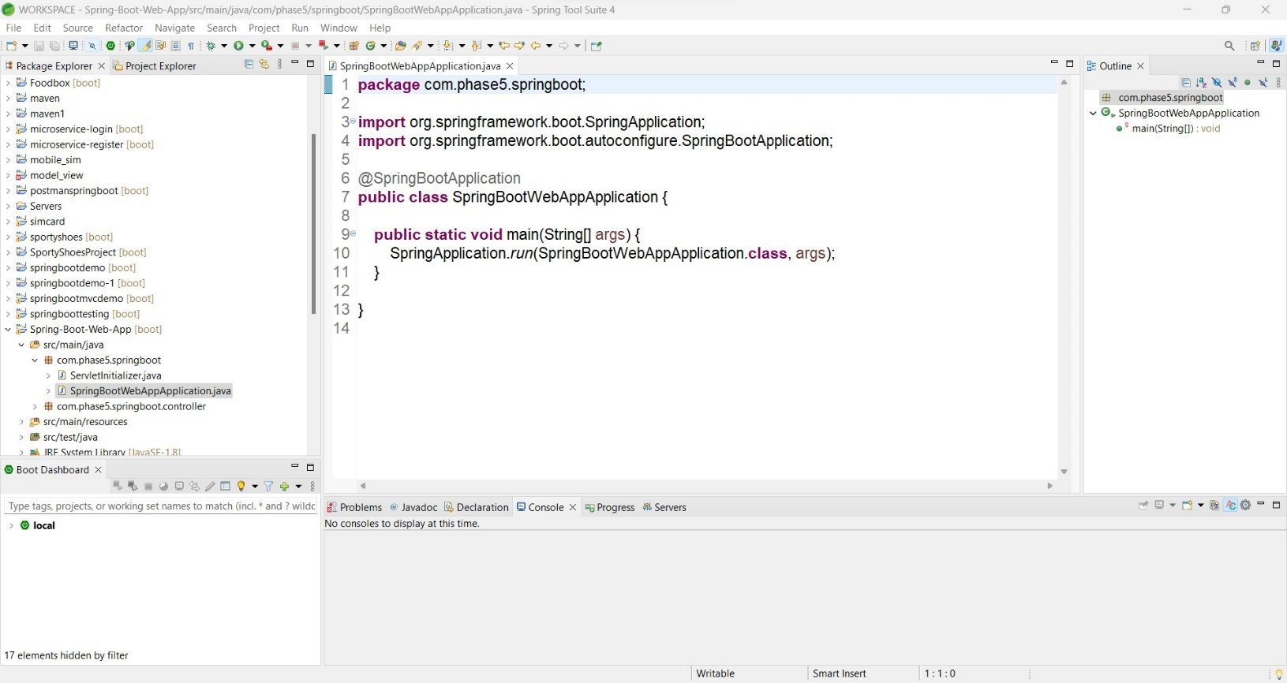

# Step 2: Launching EC2 instance:

1. Click on launch instance to run any instance
2. Select the AMI

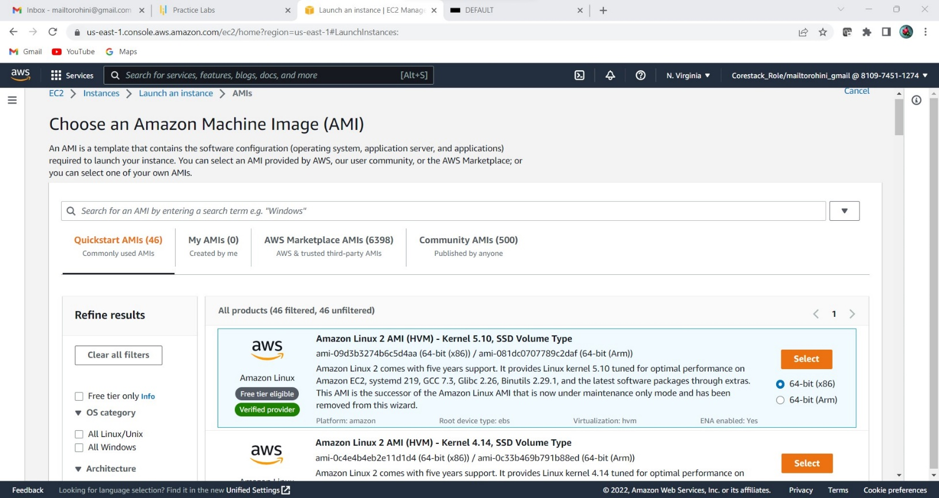

1. Select t2.micro as the instance type

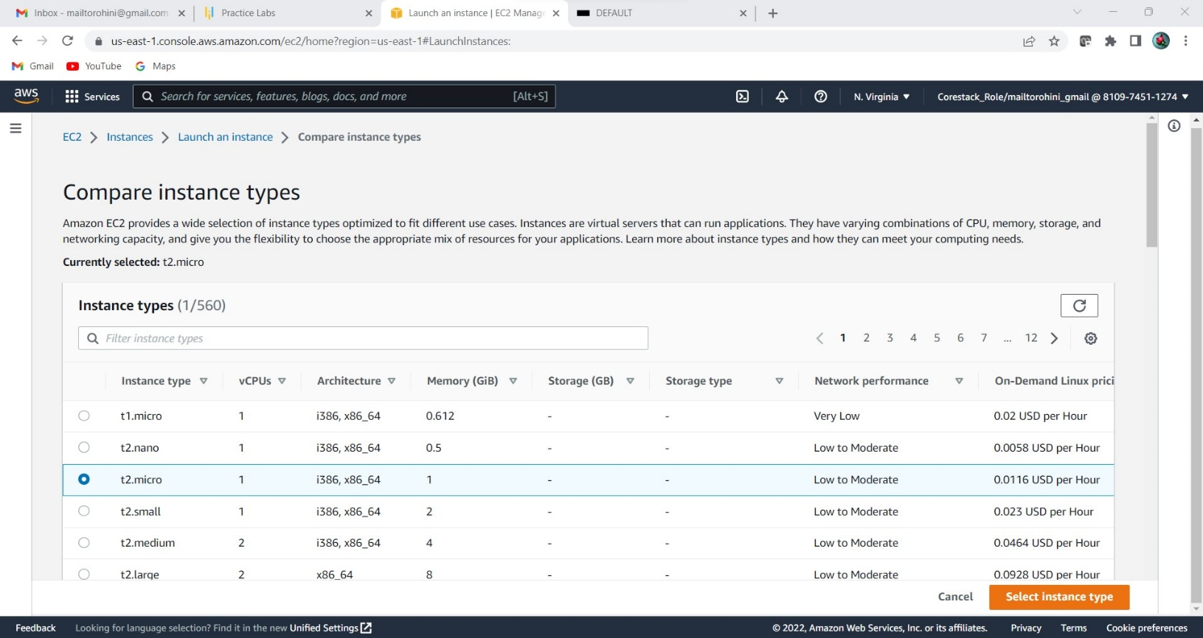

1. Specify the number of instances, networks, placement groups, and IAM roles and click Next

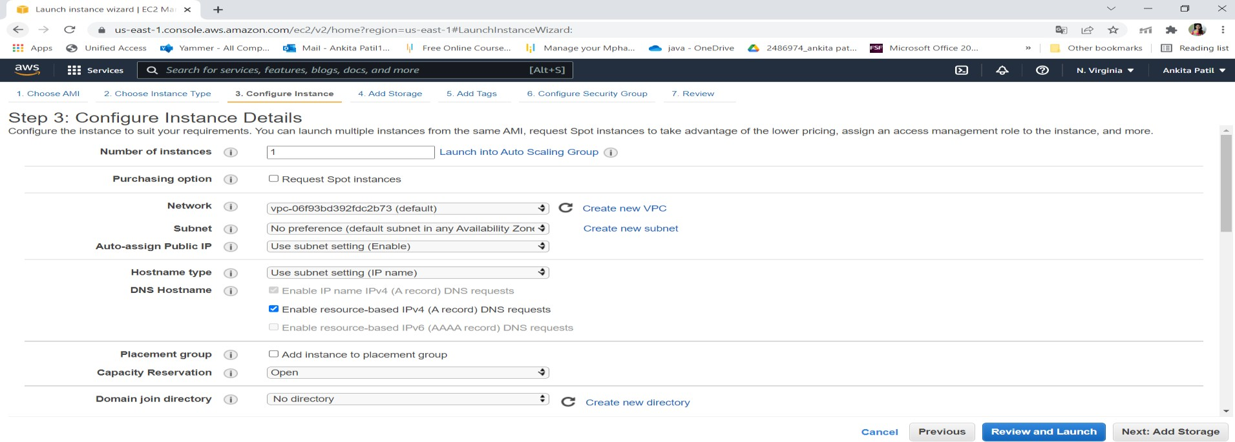

1. Add storage

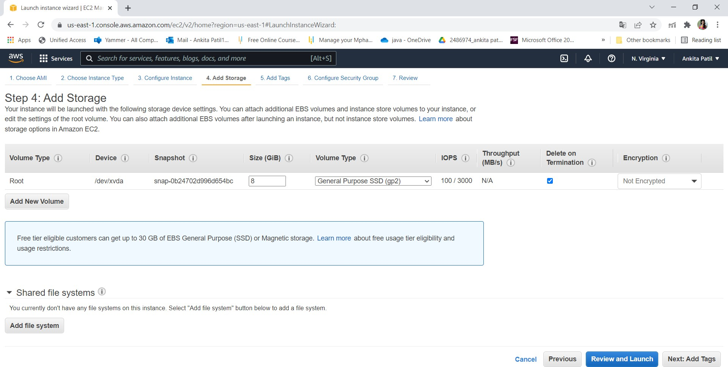

1. You can add a key-value pair to the instance

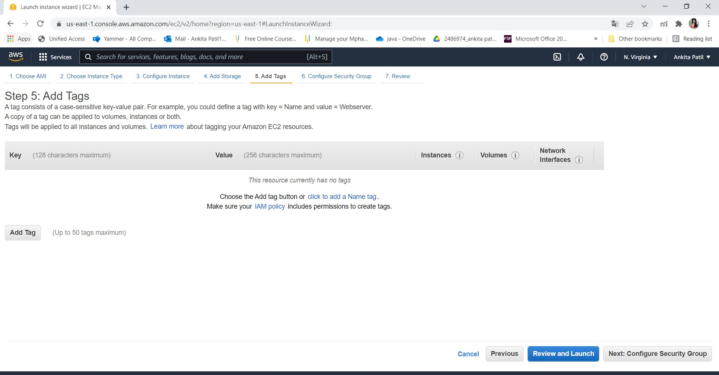

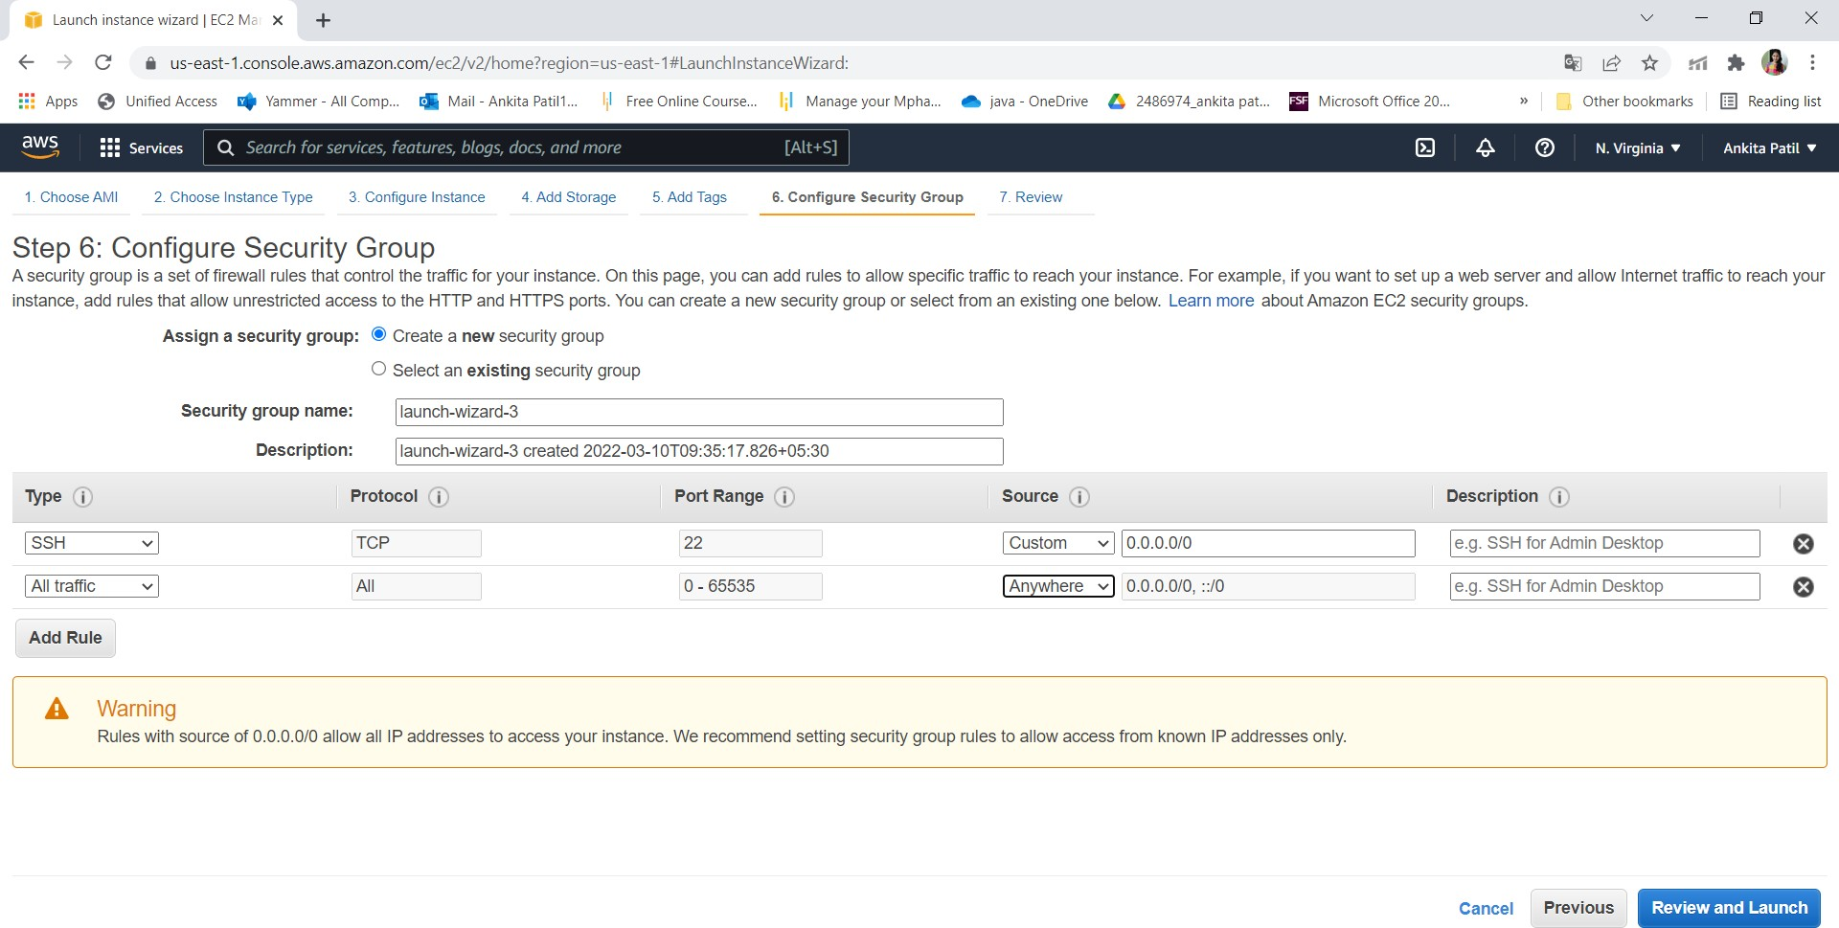

1. Click on launch

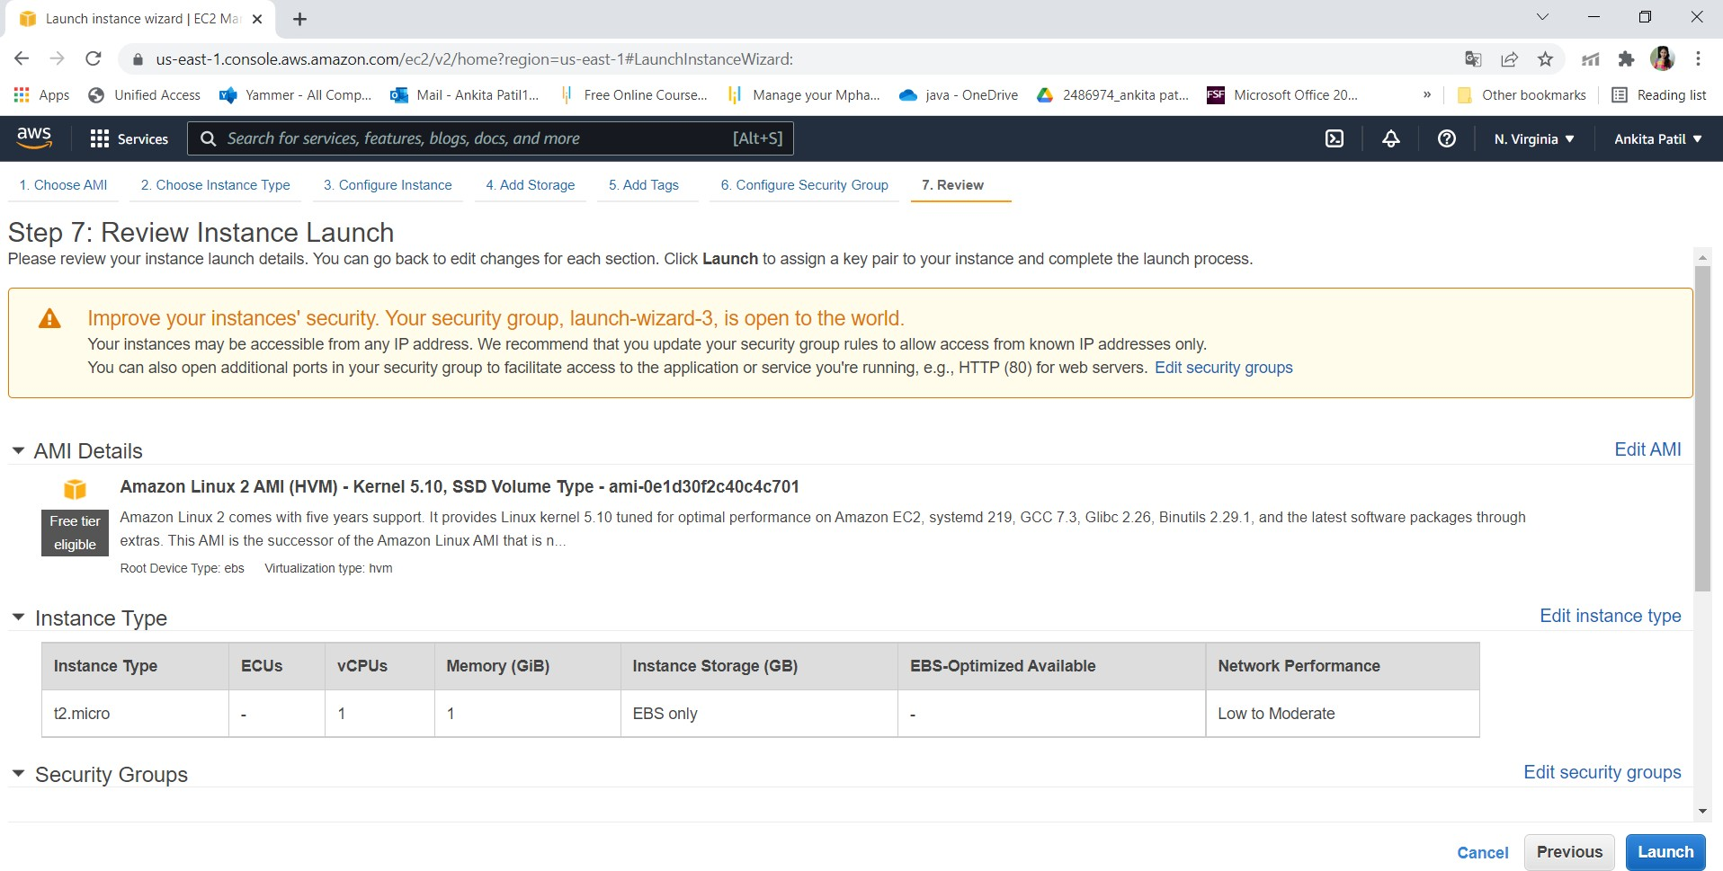

1. Create key pair

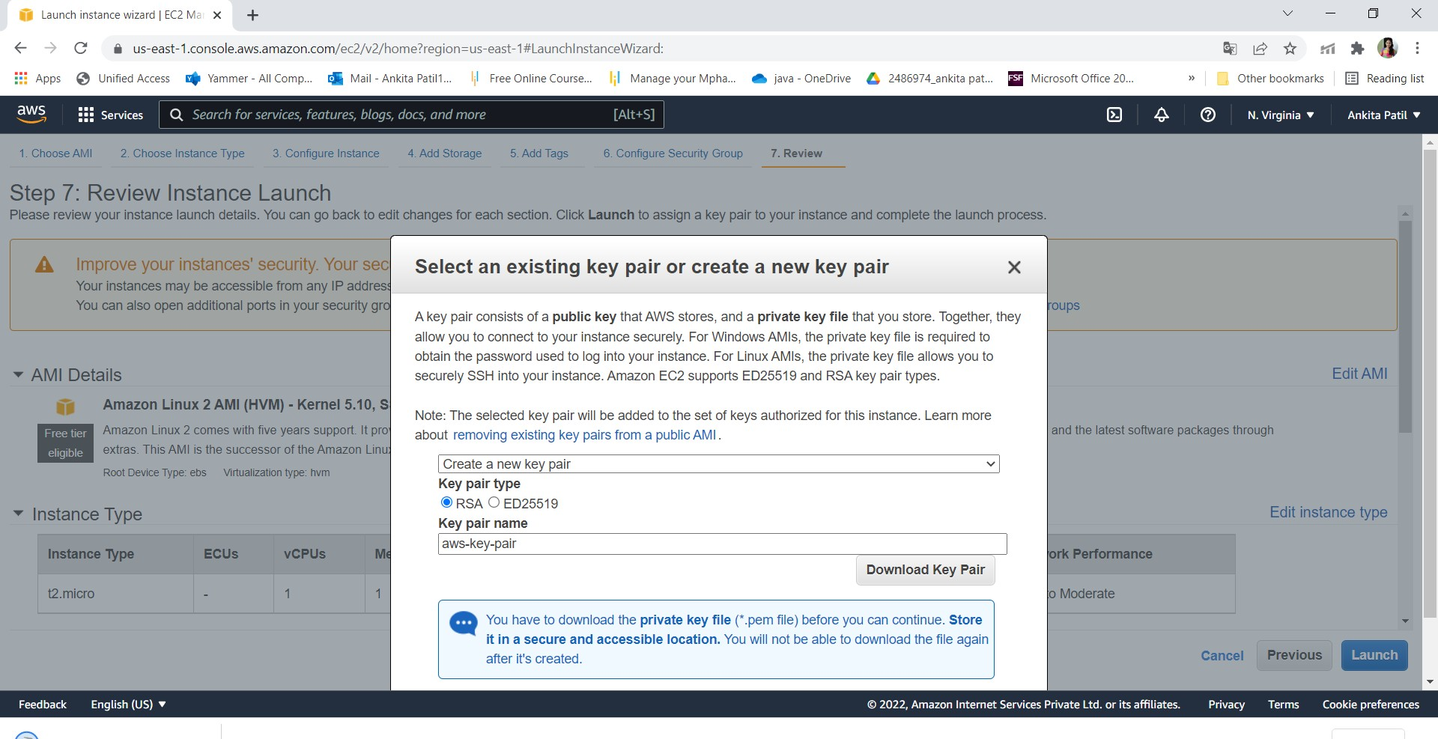

1. Click on view instance

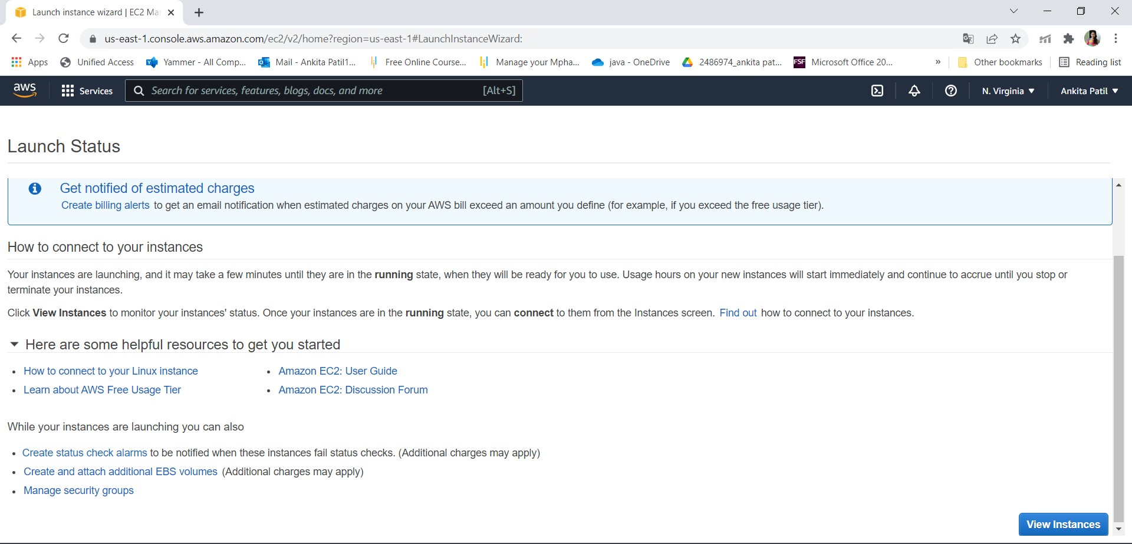

1. Connect the instance

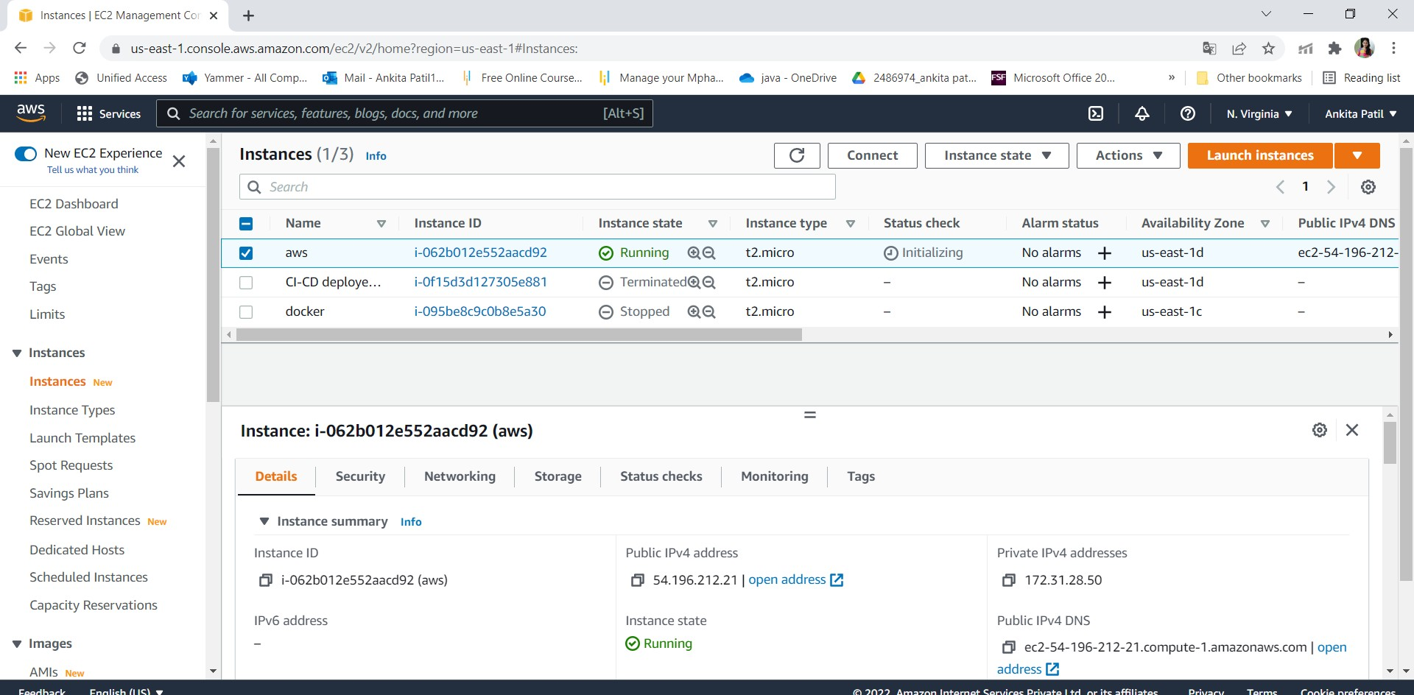

# Step 3: Connect to EC2 instances:

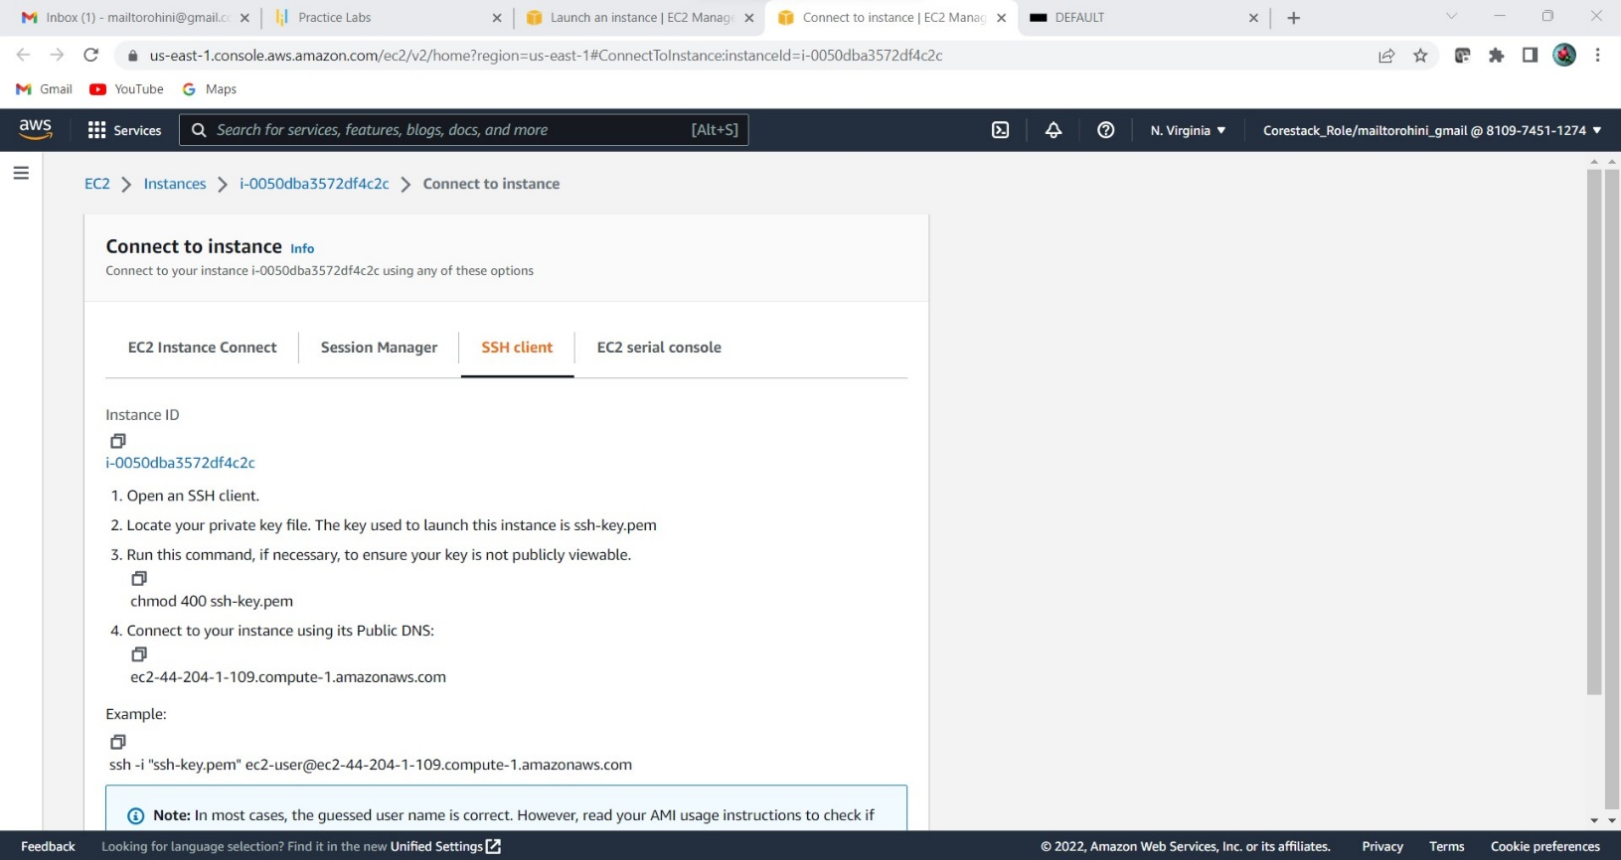

1. Click on Connect on EC2 dashboard & Run the ssh command provided

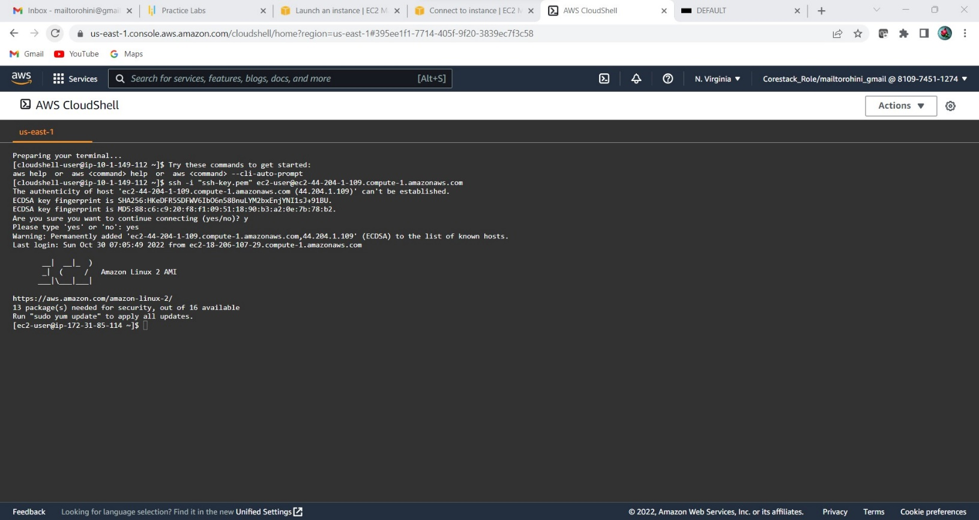

# Step 4: Creating S3 Bucket:

* 1. Create Bucket to store jar file:

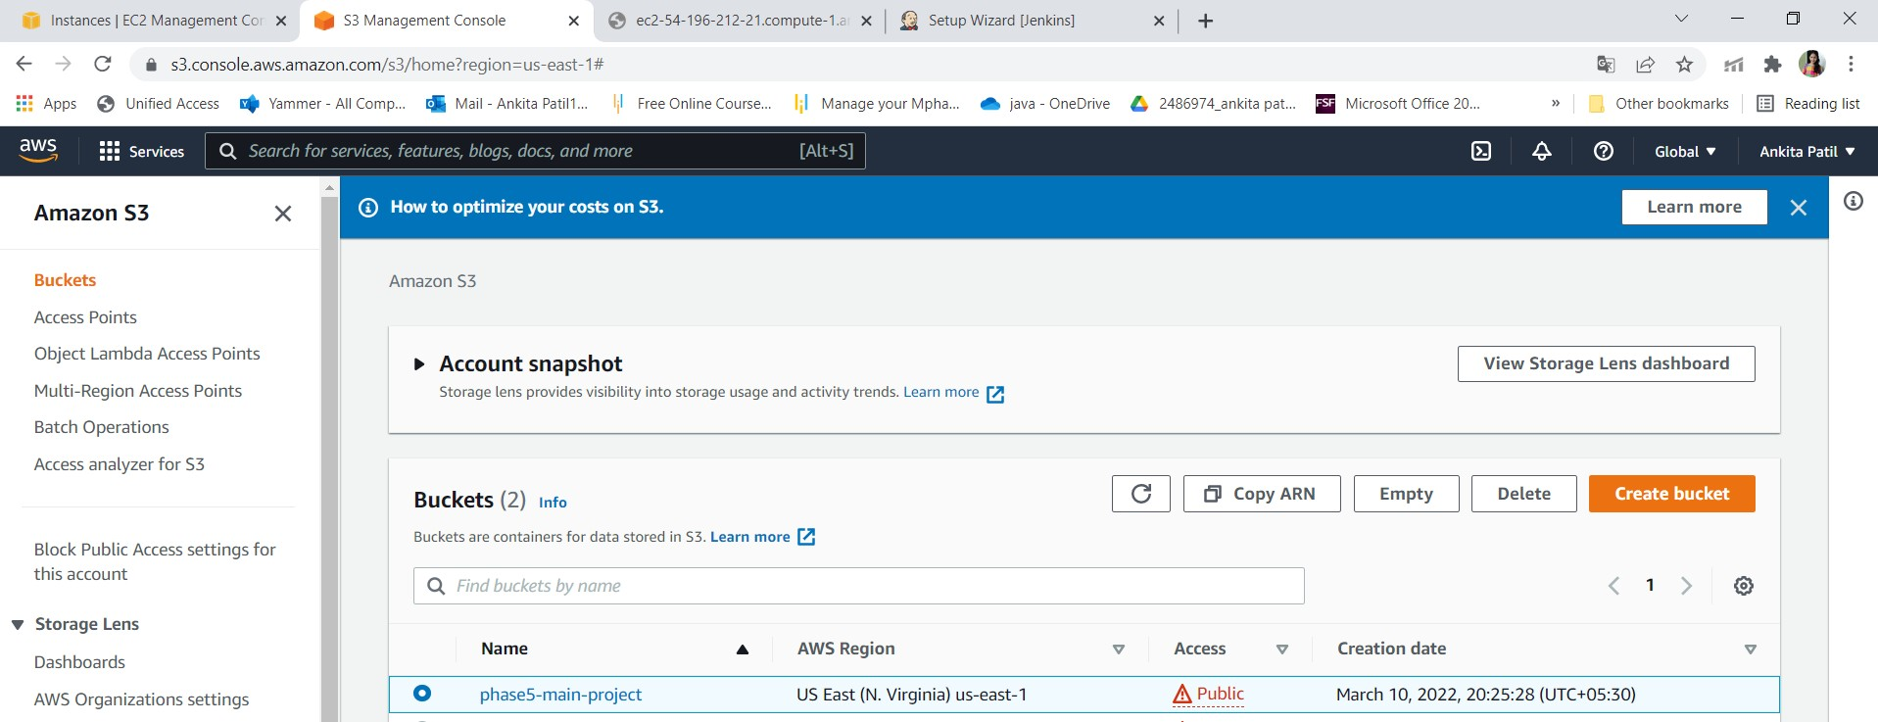

Step 5:Adding jar file:

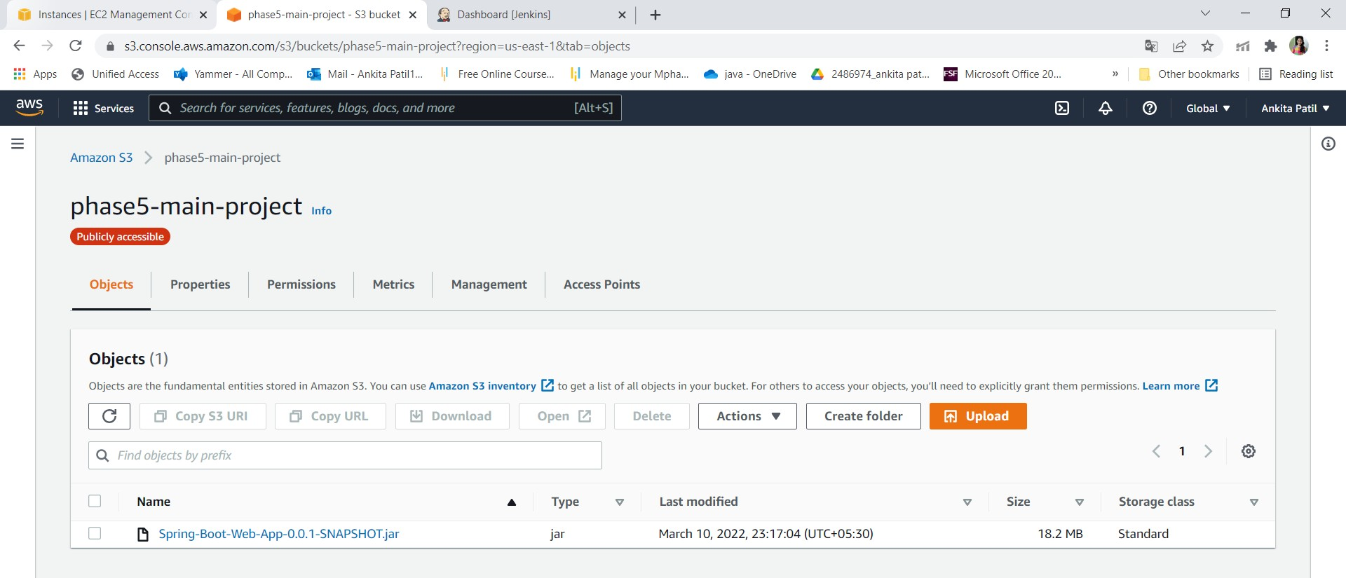

* + Run program through instance:

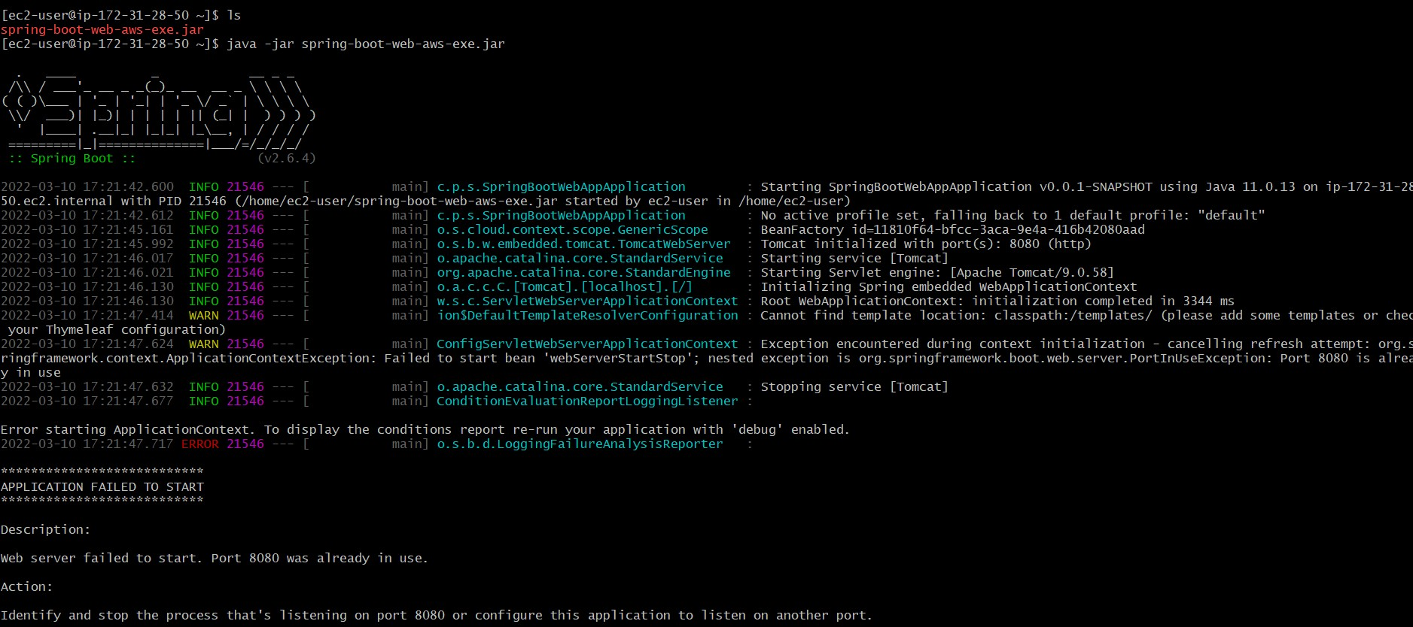

* + Output:

